Suicide Prevention & Gospel Care

Dr. Timothy Allchin, Executive Director, Biblical Counseling Center

The Difficult News on Suicide in America

- In 2016, nearly 45,000 Americans age 10 or older died by suicide.
- Suicide is the 10th leading cause of death and is one of just three leading causes that are on the rise.
- More than half of people who died by suicide did not have a known diagnosed mental health condition at the time of death.
- Firearms were the most common method of suicide used by those with and without a known diagnosed mental health condition.
- Overall suicide rates increased 28% from 2000 to 2015.
- It is the third leading cause of death for youth 10–14 years of age, the second leading cause of death among people 15–24 and 25–34 years of age; the fourth leading cause among people 35 to 44 years of age, the fifth leading cause among people ages 45–54 and eighth leading cause among people 55–64 years of age.

On the charts on the next page, you will see the various risk factor, warning signs and prevention strategies that researchers have identified as impacting the rates of suicide in our society. As a counselor, you should become familiar with the warning signs but also understand that many suicides didn’t seem to have demonstrable warning signs at all. We should not set the expectation that we can prevent all suicide, but we can do better in helping to prevent cases where warning signs are present. Even those who don’t know what to say can have a huge impact just by choosing to be with and persuading/helping the suicidal person to seek help. Even the little things matter as they give glimmers of hope. The glimmers of hope save lives and represent that love of God and the dignity of his creation.

Suicide Risk Factors

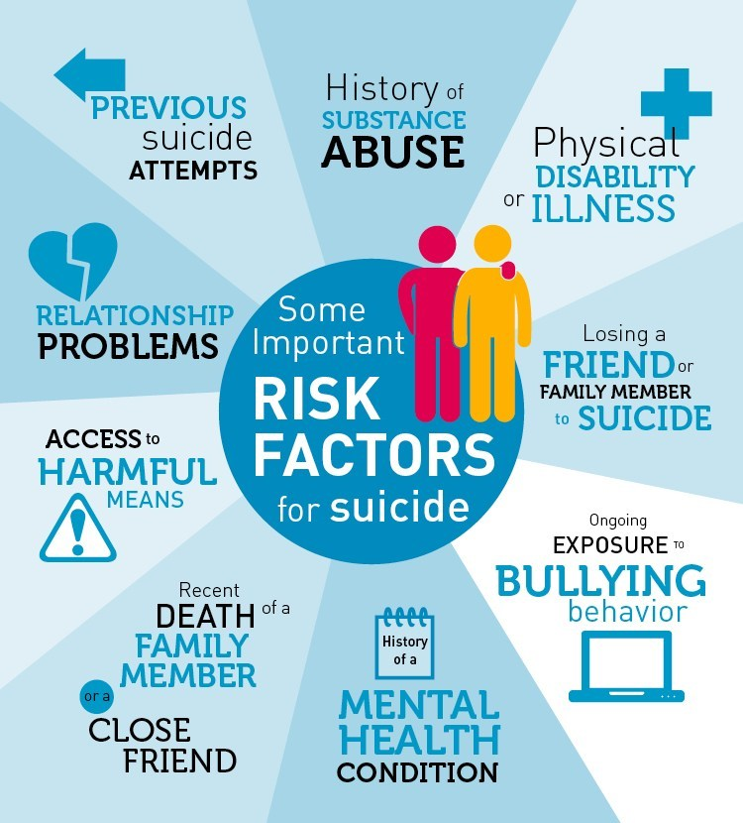

Suicide Warning Signs

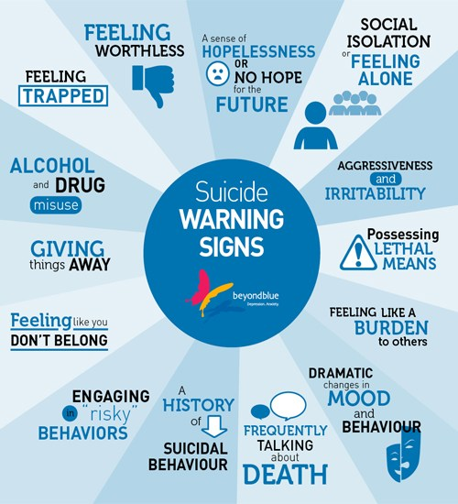

Suicide Prevention Stragies

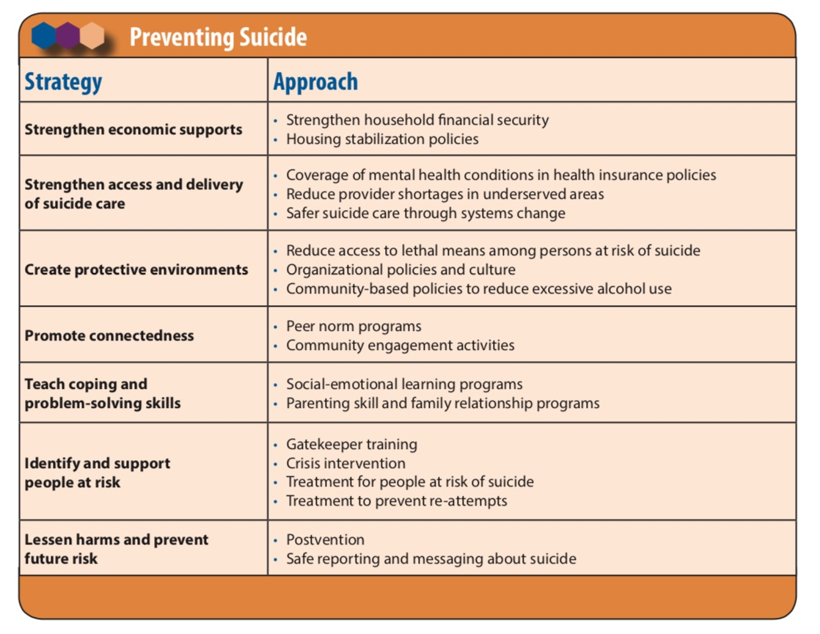

From a biblical counseling viewpoint, we might represent the complicated interaction of people like this. Notice, we anchor this in the purpose that God created us and his active ability to bring hope to those who trust him. However, we also recognize the body and emotions as factors that must be addressed in the counseling process. Biblical Counseling does not limit our counsel to “spiritual advice” but recognizes that all dimensions of man must be dealt with.

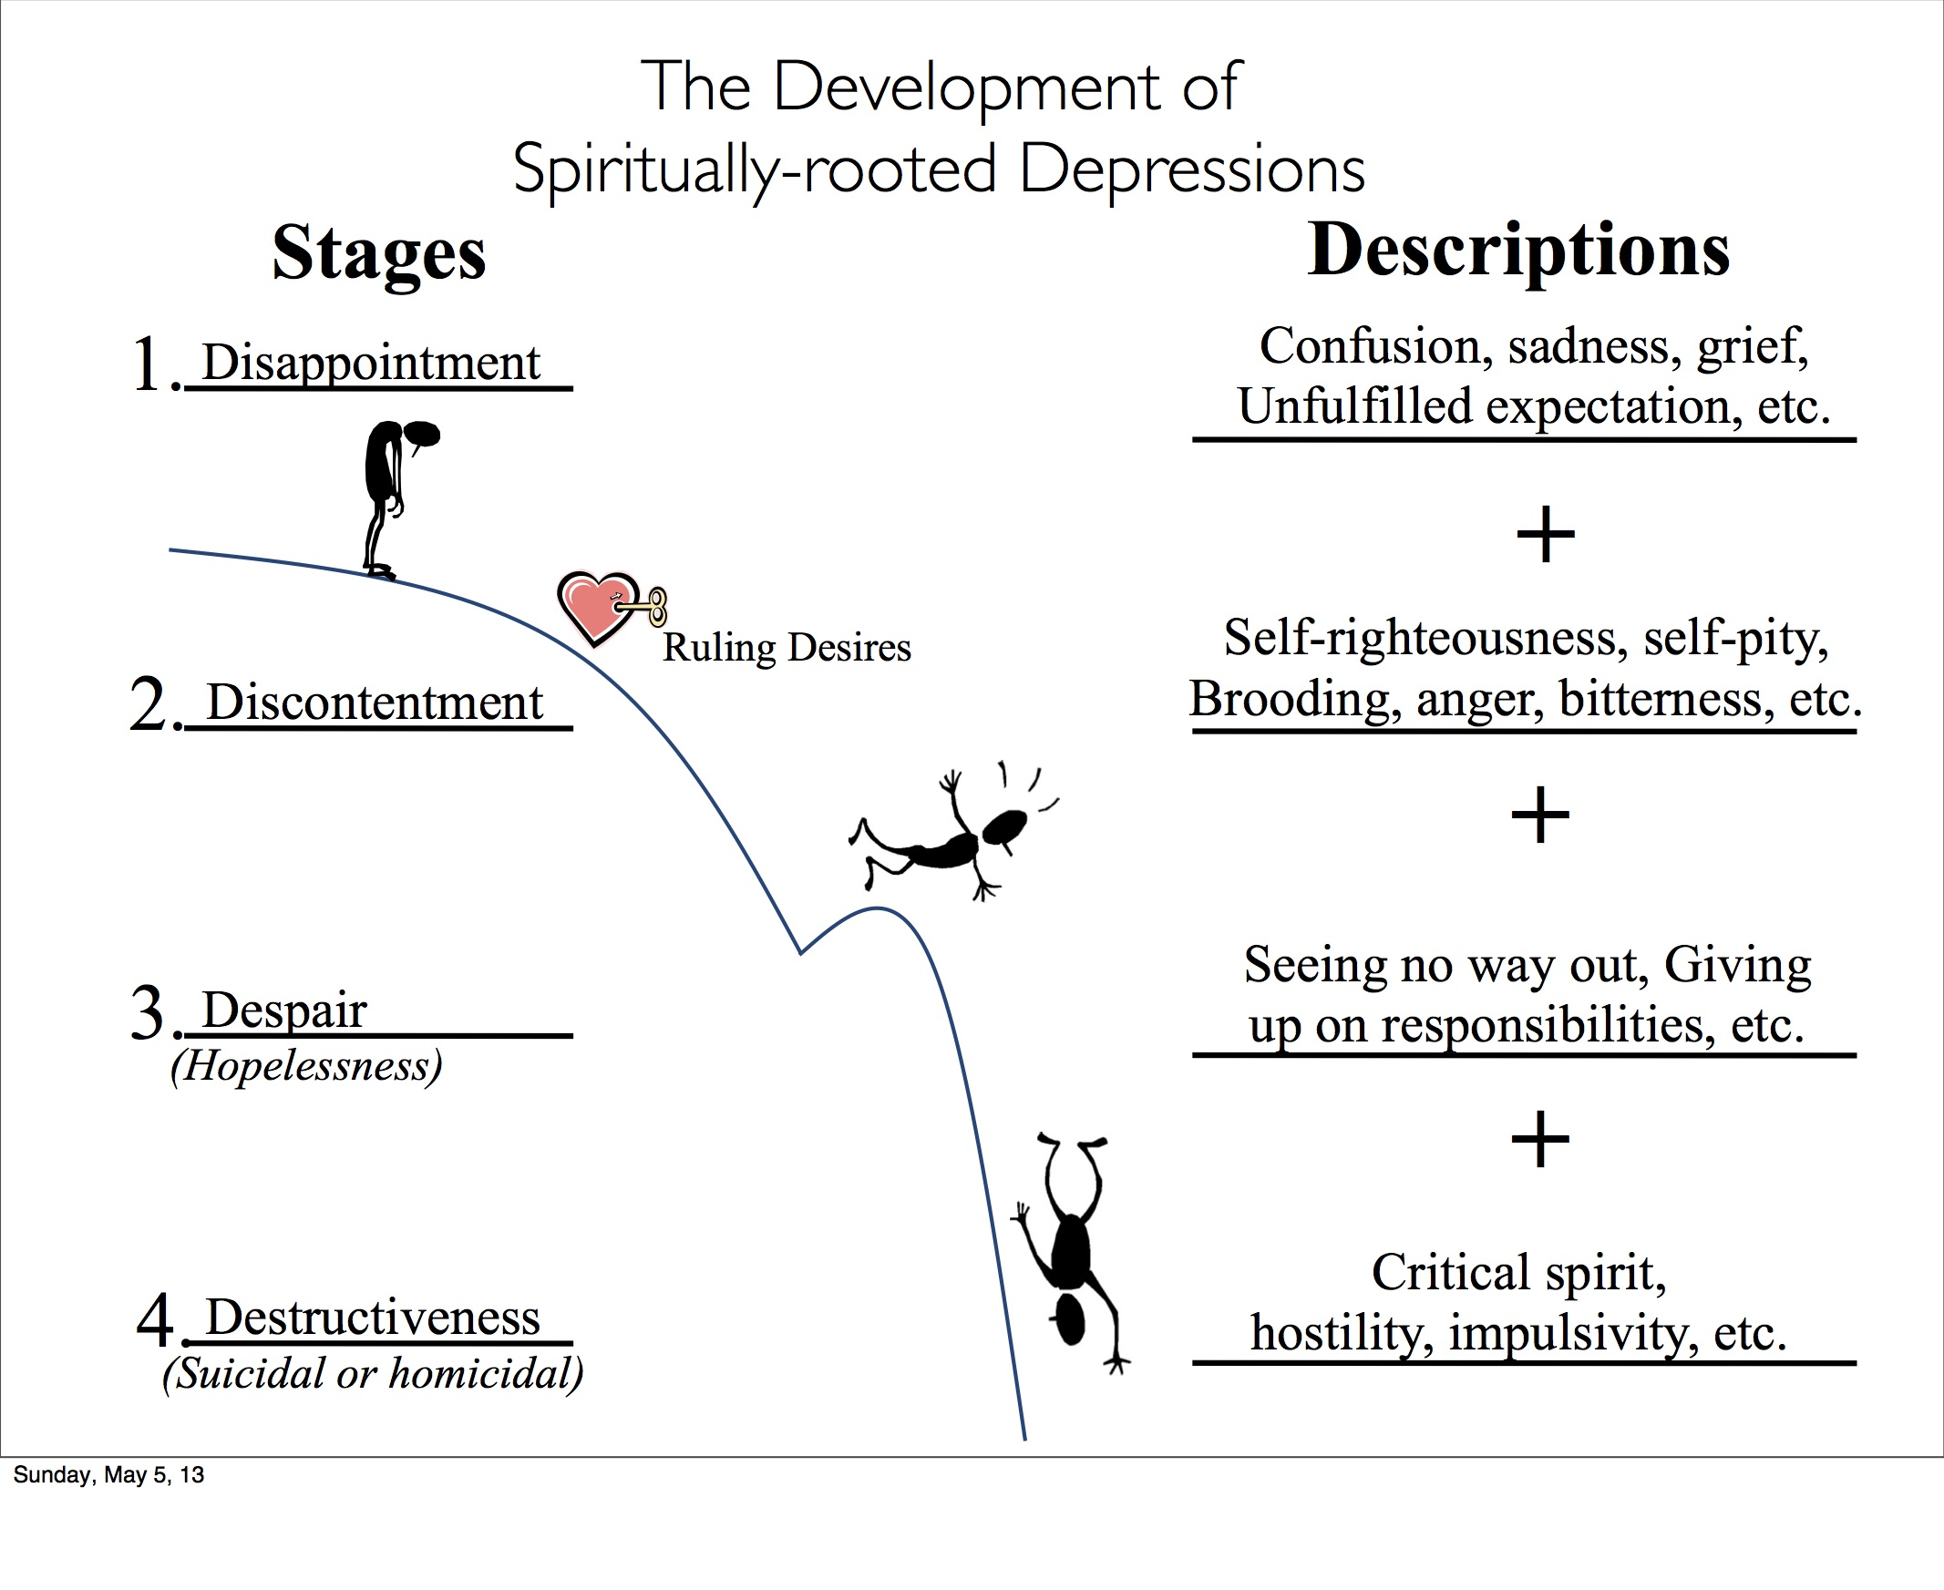

https://www.cdc.gov/media/releases/2018/p0607-suicide-prevention.html
https://www.thefyi.org/risk-factors-for-suicide-infographic/
https://cellcode.us/quotes/suicide-signs-common-warning.html
CDC Guide Community Scale Suicide Prevention Strategies

